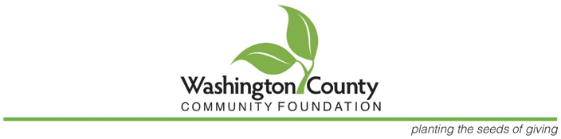

For Immediate Release  
Date: June 19, 2025  
Contact: Molly Dahlgren - 402-426-8989

**Washington County Community Foundation works toward reaching goal of $15 million by   
25th Anniversary**

**BLAIR, NE -** The Washington County Community Foundation (WCCF) is proud to celebrate nearly 25 years of serving our community with a major campaign to grow its impact and ensure a strong future for Washington County.

With deep gratitude, we reflect on the progress we have made together with our community support. The Foundation now operates from our own office in Blair, where our presence in the county is stronger than ever. The Foundation has a committed team including the Executive Director and new Coordinator, as well as 15 dedicated board members who keep the Foundation’s work moving forward with care and professionalism. And thanks to our generous donors who are individuals from all corners of the county who have shared their time, talent, and treasure, we continue to grow and give back.

In the past year alone, WCCF, awarded $156,000 in grants to local nonprofit organizations, funding that helps strengthen programs and services right here at home. We also continue to support and recently awarded nearly $70,000 in scholarships to local students! In addition, the Foundation manages over 50 Donor Advised Funds, each tailored to align the donor’s personal values with the needs of their favorite causes.

These achievements are just the beginning. As WCCF approaches its 25th Anniversary at the end of 2025, the next major goal is within reach: managing $15 million in total assets. Currently, the Foundation holds approximately $13.4 million, and is launching a campaign to raise just over $1.5 million to meet this milestone.

“We believe in the power of community,” said Molly Dahlgren, Executive Director of WCCF. “This campaign is about more than just a number. It’s about increasing the scholarships and grants we can award, supporting nonprofits with limited resources, and strengthening our county for generations to come. The more the Foundation has, the more we are able to give. The opportunities are endless with donor support.” Information concerning grants, such as the amount awarded and how the money was used, is available on the Foundation web site.

As WCCF looks toward the future, we invite you to be part of this meaningful effort. Every donation, no matter the size, makes a difference. Together, we can double our impact and ensure that even more support reaches the people and organizations who need it most.

Please consider making a thoughtful gift to the Washington County Community Foundation. Your generosity today will create a legacy of giving for tomorrow. To donate or learn more, visit www.washcocommfoundation.org or call Molly at 402-426-8989.

**About the Washington County Community Foundation:**  
  
WCCF is dedicated to improving the quality of life in Washington County by connecting generous donors to meaningful community needs. The Foundation supports charitable projects, manages donor-advised funds, and awards scholarships and grants to benefit our local communities.