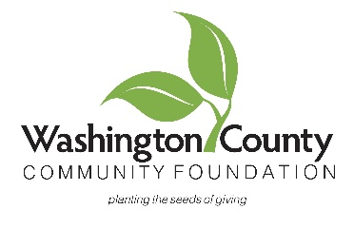

FOR IMMEDIATE RELEASE Contact: Molly Dahlgren – 402-426-8989

Date: November 1, 2024

Washington County Community Foundation Aims for $15 Million in Assets by Year-End 2025

Blair, NE - The Washington County Community Foundation (WCCF) is excited to announce its ambitious goal of reaching $15 million in assets by the end of 2025. Currently, the Foundation stands at $10 million in assets and is committed to expanding this figure in celebration of its 25th anniversary in 2025.

The Washington County Community Foundation is dedicated to enhancing the quality of life in Washington County by providing a means for individuals to make tax-deductible contributions towards charitable causes. The Foundation’s mission is to foster philanthropy and empower donors to make a lasting impact in their community.

Since its inception, the WCCF has played a vital role in supporting the philanthropic efforts of numerous nonprofit organizations across the county through scholarships and grants. In the past year alone, the Foundation awarded over $89,000 in grants and $18,000 in scholarships, enhancing the lives of countless community members and advancing meaningful projects throughout Washington County.

“Our growth directly translates to our ability to support even more impactful initiatives within our community,” said Molly Dahlgren, Executive Director of WCCF. “We believe that with the right support, we can make Washington County an even better place to live for everyone.”

To kickstart this growth, the WCCF invites community members to make a charitable donation by visiting its website or stopping by the office located at 1615 Washington Street. Another opportunity to give will be through the Washington County Gives campaign on December 3rd. On this annual day of giving, donors may contribute to the Foundation and other 501 (c) (3) organizations, both benefitting the Foundations goal of reaching $15 million in 2025.

“Your generosity can have a lasting impact on our community. Together, we can continue this tradition of giving and make a real difference in the lives of our neighbors,” Dahlgren added.

For more information on how you can make a difference, please visit washcocommfoundation.org or contact Molly Dahlgren at 402-426-8989.